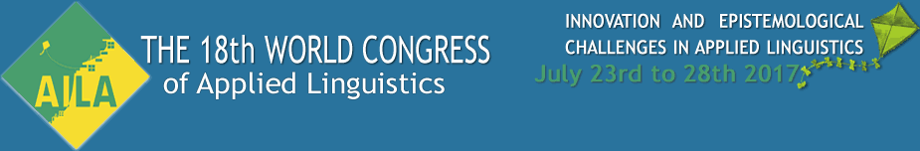

**Call for papers: HoLLT.net Colloquium on 'History of Language Learning and Teaching: Perspectives on Innovation' at the AILA Congress, Rio de Janeiro, 23–28 July 2017**



HoLLT.net (<http://www.hollt.net>) is a Research Network of AILA ('L'association internationale de linguistique appliquée - International Association of Applied Linguistics) which was founded in 2015 to stimulate research into the history of language learning and teaching within applied linguistics internationally.

As a Research Network of AILA, we are expected to organize a half-day colloquium at the AILA Congress every three years. The next Congress will be in Rio de Janeiro at the end of July 2017 (further information: <http://www.aila2017.com.br/index.php>) and we are proposing a colloquium on 'History of Language Learning and Teaching: Perspectives on Innovation', to correspond with the overall conference theme of 'Innovation and epistemological challenges in applied linguistics'.

Proposal abstracts of 250 words are therefore invited which address the theme of innovation from a historical perspective. If you would like to be considered for participation in this colloquium, please send your presentation title, your name and email address, and your 250-word abstract to: R.C.Smith@warwick.ac.uk **by 30 September 2016**.

Abstracts may be written in English or French, and the language of presentation may be English, French, Portuguese or Spanish, with textual support in one other of these languages.

Candidates will be informed of the results of review by 31 October 2016, allowing ample time for early-bird registration before the cut-off point of February 2017. Please note that as an AILA Research Network we are allowed to set a special deadline for proposals, later than the overall conference call for papers, which has now closed.

Best wishes

Giovanni Iamartino, Friederike Klippel, Nicola McLelland and Richard Smith

Joint convenors, AILA Research Network on History of Language Learning & Teaching