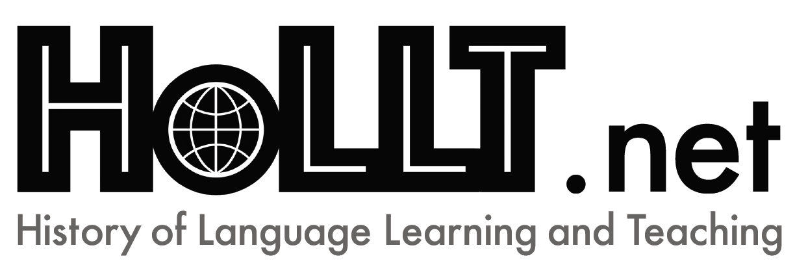
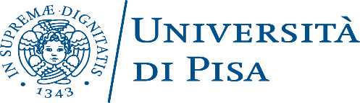
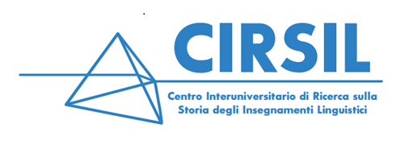
14th CIRSIL conference
Supported by HoLLT.net (AILA Research Network on History of Language Learning and Teaching)
Language Teaching: Pedagogy and Ideology
September 24th – 25th, 2020
Polo Congressi Le Benedettine, Piazza San Paolo a Ripa d’Arno 16, Pisa, Italy

The conference aims to investigate the complex relationships between language teaching and dominant ideologies in the modern and contemporary age from a historiographical perspective. Proposals are encouraged which focus on how economic, political and social power relations, apparently foreign to linguistics and language teaching, have influenced over the centuries the creation of didactic tools, the structuring of different approaches, the teaching of minority languages, debates on teacher training, and so on.

The areas of study envisaged include the following:

- Lexicographical repertories
- Grammars
- Handbooks and conversation guides
- Methodological approaches and glottodidactics
- Training and curricula for students and teachers
- Language norms
- Language varieties
- Language policies

Open session
The call also includes an open session on the teaching of second or foreign languages, in relation to the traditional research topics of CIRSIL.

Important dates

February 15th, 2020 Deadline for sending proposals to cirsil2020@unipi.it
Proposals may be submitted in Italian, French, English, Portuguese, Spanish or German, and must contain a title and a summary (maximum 500 words, excluding references). The use of slides in a language other than the language of presentation (Italian or English) is recommended.
March 15th, 2020 Acceptance of proposals (Acceptance will be communicated by e-mail).
September 24th-25th, 2020 Conference.

Scientific committee
Monica Barsi, Claudia Buffagni, Elena Carpi, Roberta Cella, Rolando Ferri, Francesca Gallina, Giovanni Iamartino, Monica Lupetti, Félix San Vicente.

Organising committee
Elena Carpi, Guido Ferrini, Monica Lupetti.
Email: cirsil2020@unipi.it
Further information will be provided on the conference web page (under construction) and on the CIRSIL ((Centro Interuniversitario di Ricerca sulla Storia degli Insegnamenti Linguistici) website: https://cirsil.it/category/notizie-ed-eventi/

Further information:
Elena Carpi elena.carpi@unipi.it
Monica Lupetti monica.lupetti@unipi.it
Nicoletta Spinolo nicolett a.spinolo@unibo.it

